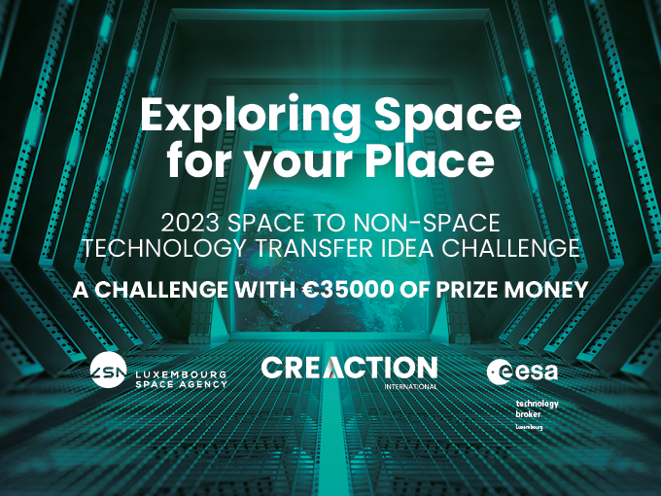

Exploring Space for your Place

2023 Space to non-Space Technology Transfer

Idea Challenge

Introduction

In its role as ESA technology broker for Luxembourg, Créaction International is organizing a Space to non-Space Technology Transfer Idea Challenge with €35 000 of prize money funded by the ESA Commercialization Gateway and supported by the Luxembourg Space Agency, which is open to all companies, independent of their sector, operating on the territory of the Grand Duchy of Luxembourg.

Between now and 25 September you are invited to submit a technology idea/challenge or describe a technological problem relating to a new or existing product, process or service for which you have identified a potential solution developed by ESA or a company working in the space sector in Luxembourg. The challenge which is selected by the evaluation panel as having the most promising match between the idea or problem and the space solution will receive prize money of €35 000 in order to study the potential of the transfer and carry out a pre-validation of the match.

How to apply?
Interested applicants should complete the 5-part application form below. It comprises
(1) the contact details of the company with a technology idea/need, (2) the contact details of the space technology solution provider, (3) a description of the non-space problem or technology idea/challenge, (4) a description of the envisioned space technology which could offer a solution to the problem/challenge, (5) a description of the pre-validation steps.

The closing date for applications is Monday 25 September 2023 (to be sent to creaction.international@gmail.com)

Evaluation, selection and award of prize money

The applications will be evaluated during the last week of September by an evaluation board consisting of three technology transfer experts, an expert nominated by Créaction, an expert nominated by LSA and an expert nominated by ESA. The evaluation board will use the same evaluation grid provided by the organizer in order to give their individual assessment of each of the applications. The application which receives the highest average score from the three evaluators as having the most promising match between the idea/challenge and the space solution will be awarded the prize money of €35,000.

The winner will be invited to receive their prize at an LSA Breakfast Event on 24 October 2023.

Créaction will be on hand to provide back-up support to the company to maximize their chances of success in transferring the technology.

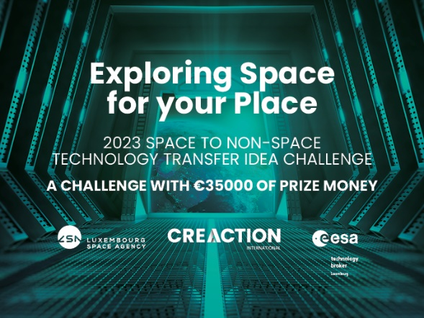

APPLICATION FORM
“EXPLORING SPACE FOR YOUR PLACE”
2023 SPACE TO NON-SPACE TECHNOLOGY TRANSFER
IDEA CHALLENGE

Company (Non-Space, Technology Idea)

Entity
Contact Name
Contact Email
Contact Phone

Company (Space, Technology Solution Provider)

Entity
Contact Name
Contact Email
Contact Phone

Idea or problem description (non- space)

Envisioned solution based on a space technology

Description of steps to pre-validate the match between the idea/ problem and the potential solution, e.g. prior art study, comparison of competing technological solutions, a test, proof of concept

To be returned by email to creaction.international@gmail.com or by post to Créaction International, 67 rue du Château, L-1329 Luxembourg by 25 September 2023

